Review and update of the Plan 2013-14 to 2017
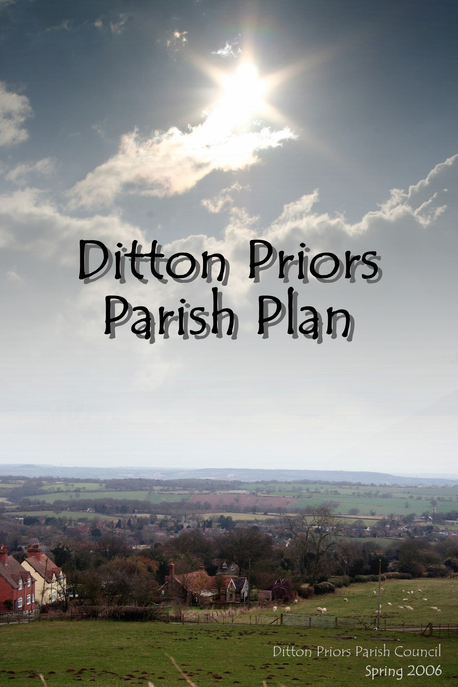

Executive Summary

We have pleasure in presenting the Review and Updated Parish Plan for the parish of Ditton Priors. It records the views of our community, how they see their parish and their hopes and aspirations for the future.

This updated plan was initiated by the new Parish Council in 2013.

The action plan has been presented to the Parish Council and has been adopted on 13th February 2014. The Parish Council will oversee its progression in the future.

Ditton Priors is not alone in producing an updated Parish Plan and joins many other parishes that wish to play a larger and stronger part in determining their future. Many of the initiatives identified within the plan do not lie wholly within the scope of the Parish Council. They will rely on the co-operation between any number of organisations both within and outside the parish. Given the credibility of this research we are confident that parish and voluntary organisations within the Parish and Shropshire Council will work together to achieve these ends.

It is clear that the Parish Plan is not an end product but is a beginning, leading our community to take a larger role in deciding its future.

Our thanks go to all who have assisted us with this project. We commend this to you all.

Introduction to Ditton Priors

Ditton Priors is a large rural parish administered by Shropshire Council and Ditton Priors Parish Council. It includes the hamlets of Middleton Priors, Derrington, Ruthall, Upper and Lower Netchwood and Ashfield, with a total area of 5000 hectares and a current population of about 750 people with 330 dwellings. The nearest towns are Bridgnorth, 7m to the east and Ludlow, 12m to the south. It is within easy commuting distance of Shrewsbury, Telford and the Black Country.

The parish lies partly within the Shropshire Hills Area of Outstanding Natural Beauty. The village centre is 230m above sea level at the foot of the Brown Clee Hill which is surmounted by an ancient hill fort. It is an important leisure area for the West Midlands with obvious tourist appeal and part of the village is protected as a conservation area. The church of St John the Baptist dates back to the 12th century and is surrounded by the old cottages and houses of the village, built in the dark basalt called dhustone which was formerly quarried on the summit of the Brown Clee.

Traditionally Ditton Priors has always been dominated by agriculture but, although still surrounded by farmland, today fewer people are directly connected with farming. A former Admiralty Second World War armaments depot has been converted into a 3 hectare industrial estate, consisting of about 20-25 units for light industrial use, not only offering employment to local people but also bringing in workers from the surrounding area. Modern development and conversion of older buildings have provided homes for families, many of whom commute to work in the West Midlands. By and large this makes for a mixed-age community, although it is particularly popular with retired people. There are two privately owned residential homes for the elderly, with close links to this caring community. Similarly, residents take pride in Oak Farm, formerly a County Council smallholding, now a centre for service users with learning disabilities.

Why update and review the parish plan

The original parish plan was written by a volunteer community group in 2005-2006. The Plan has been very successful with most of the action plan being completed. A housing needs survey led to seven affordable homes being built in Station Road for local people. The Parish Council was involved at every stage to ensure these homes were built for residents of the parish and the local area. On a lighter note a book club was formed and meets regularly. Unfortunately there were two failures, the wish to reopen closed footpaths across the industrial estate, (formerly an armaments depot), proved impossible, without costly parliamentary action. Secondly we were unable to secure a mobile fish and chip service to the parish.

How the review and update was carried out.

A questionnaire was sent to every household in the Parish. An analysis was carried out by Gill Porter at Shropshire Rural Community Council. There was approximately a 10% return of the 336 forms sent out.
Because of the low return one of the recommendation is that further consultation is needed before major conclusions can be drawn. However the survey does give an indication of the needs in the Parish. The full analysis is available on The Parish Council website. www.dittonpriorsparishcouncil.co.uk. Follow the links to the Parish Plan page. The housing needs survey is also available as part of the same document.

As a result of the surveys an action plan has been drawn up from the results.

Contacts

For more information contact clerk to the Parish Council Mrs Jayne Madeley BA FILCM 01746 785571 dittonpriorspc@btinternet.com or Cherry Oaks Farm 74 Lower Monkhall Monkhopton Bridgnorth Shropshire WV16 6XF.

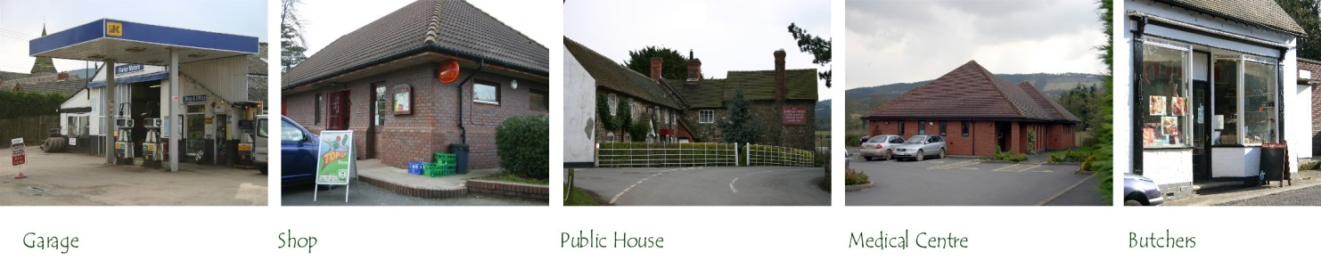

Action Plan

Issue | Lead | Partners | Action | Action by
Litter | Ditton Priors Parish Council | Shropshire Council  Volunteers | Regular litter picks | 2013
Pavement | Ditton Priors Parish Council | Shropshire Council | Provide and find funds for a pavement on top part of Station Road | 2014
Traffic speed | West Mercia Police | Ditton Priors PC | Monitor speed and take action | 2013
Road Maintenance | Shropshire Council | Ditton Priors PC | Form a plan to improve the roads in the Parish | 2014
Bus Service | Bridgnorth Community Transport  Corvedale Buzzard | Ditton Priors pc  Ditton Priors Community Land Trust | Promote the services available | 2013
Community Facilities | Village Hall Committee  Playing Fields Committee  Ditton Priors PCC |  | Keep maintained to the current high standards | ongoing
Tea Room | Sole trader | The community |  | ongoing
Mobile Phone Reception | Mobile phone companies | Shropshire Council |  | 2014/15
Jobs | Local business |  |  | ongoing
Housing | Housing association | Ditton Priors PC | Bungalows for the elderly | ongoing
Alternative energy | Village hall and playing fields committee |  | Use of community buildings to generate energy
Promote activities for the young | Village groups using newsletters and website | Ditton Priors PC | Investigate possibility of further activities with volunteers | ongoing
Gods Acre | Ditton Priors PCC |  | Create an area of wild flora and fauna | ongoing
Community Energy project | Community energy group |  | Create a volunteer group and investigate possibilities | ongoing
Reduce light pollution | Turn off street lighting after midnight | Ditton Priors PC |  | 2014
Swapping /bartering scheme | Volunteer group |  | Set up a community scheme. | 2014
Tourism | Local business/ | Community Land Trust | Encourage more tourism to the parish | 2014/15
Reduce light pollution | Shropshire Council and Bromford Housing | DPPC | Ensure all street lighting in the village is led | 2014
Community Farm | Ditton Priors Community Land Trust |  | Support the proposals. | ongoing
Community entertainment | Volunteer groups |  | Explore the possibility of a volunteer group | ongoing
Gardening club | Volunteer group |  | Set up a club interested parties | ongoing
Evening classes | Village hall and playing fields group |  | Explore the possibility | ongoing
Music tuition. | Brown Clee Community Choir |  | Promote and support | ongoing

